**Test Strategy**

**Test Plan (Total 10 test cases):**

1. Create a Player object with the default constructor.
2. Create a Player object with the non-default constructors.

-With valid field values

-With invalid field values

1. Test all the get method.
2. Test all the set method.

- With valid field values

-With invalid field values

1. Test the display method.

**Actual test:**

**--Test 1:**

Create a Player object with the default constructor.

--Test Data:

No input

--Expected Results:

playerName: “ “

playerGoal: 0

--Actual Result:

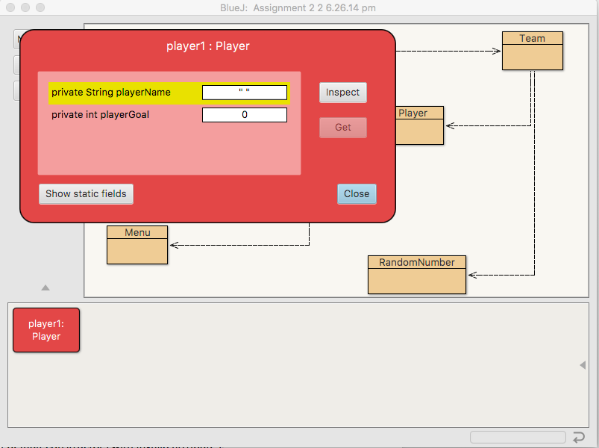

**--Test 2(a):**

Create a Player object with the non-default constructors with valid attributes.

--Test Data:

playerName: “Iron-Man”

playerGoal: 5

--Expected Results:

playerName: “Iron-Man”

playerGoal: 5

--Actual Result:

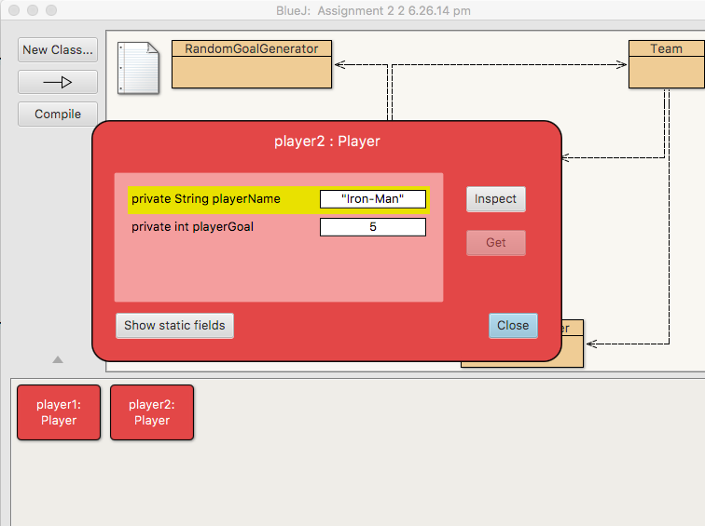

**--Test 2(b):**

Create a Player object with the non-default constructors with invalid attributes.

--Test Data:

playerName: “1234java”

playerGoal: -6

--Expected Results:

playerName: “ “

playerGoal: 0

--Actual Result:

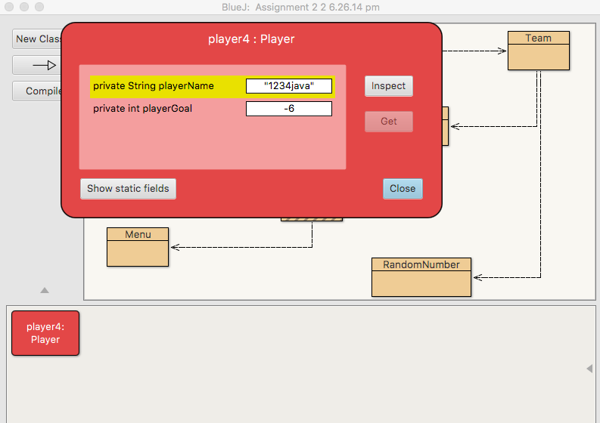

**--Test 3(a):**

Test the getName method with valid playerName input.

--Test Data:

Input playerName: “Iron-Man”

--Expected Results:

playerName: “Iron-Man”

--Actual Result:

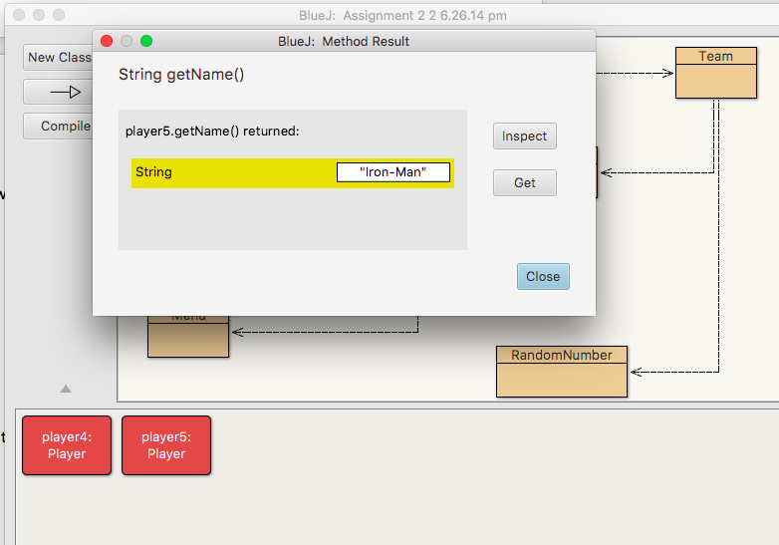

**--Test 3(b):**

Test the getGoal method with valid playerGoal input.

--Test Data:

playerGoal: 3

--Expected Results:

playerGoal: 3

--Actual Result:

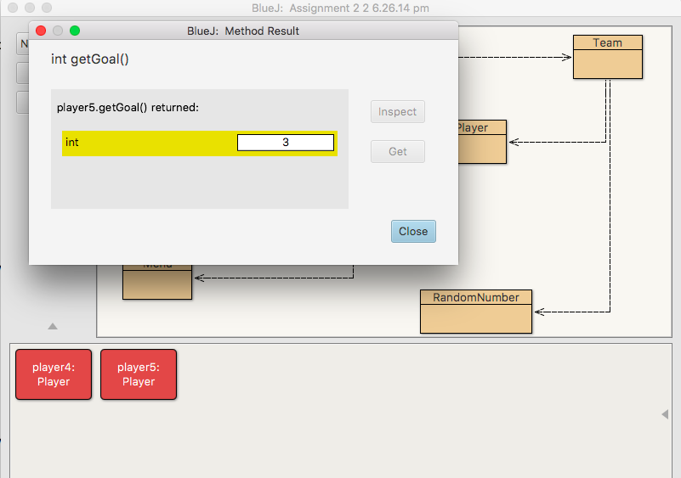

**--Test 4(a):**

Test the setPlayerName method with valid playerName input.

--Test Data:

setPlayerName: “Hello-Man”

--Expected Results:

getPlayerName: “Hello-Man”

--Actual Result:

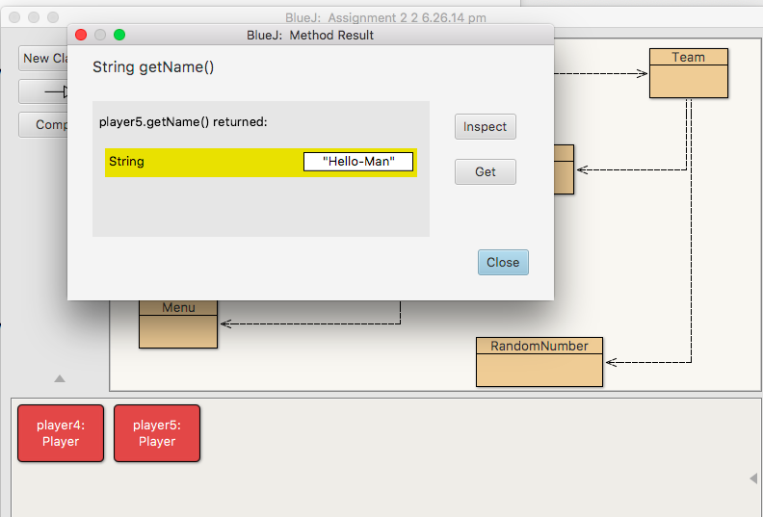

**--Test 4(b):**

Test the setPlayerName method with invalid playerName input.

--Test Data:

setPlayerName: “1234java”

--Test Results:

getPlayerName: “ ”

--Actual Result:

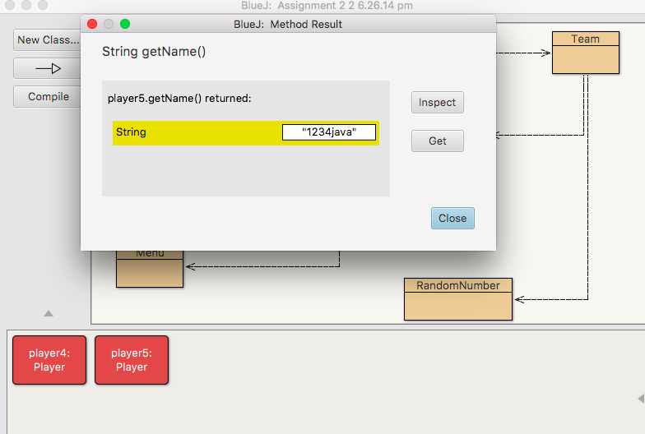

**--Test 4(c):**

Test the setPlayerGoal method with valid playerGoal input.

--Test Data:

setPlayerGoal: 5

--Expected Results:

getPlayerGoal: 5

--Actual Result:

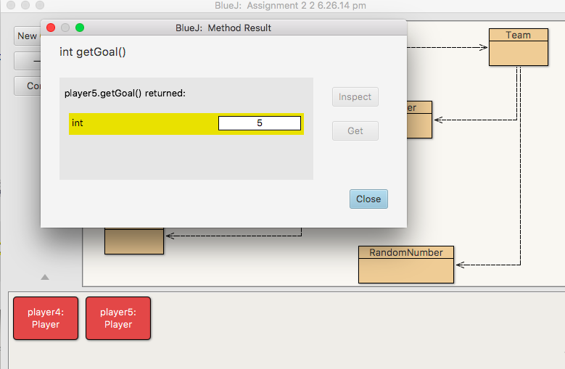

**--Test 4(d):**

Test the setPlayerGoal method with invalid playerGoal input.

--Test Data:

setPlayerGoal: -5

--Expected Results:

getPlayerGoal: 0

--Actual Result:

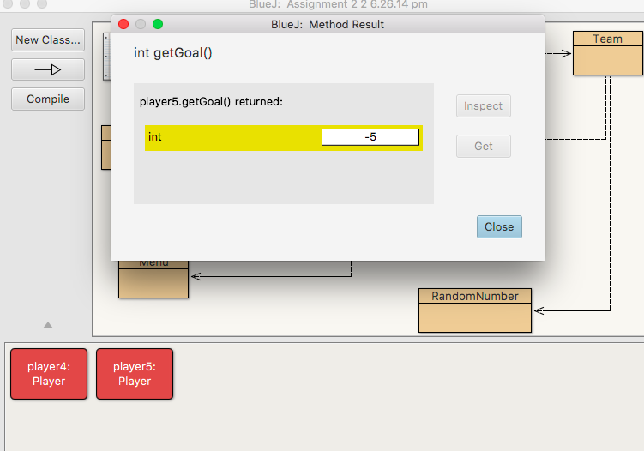

**--Test 5:**

Test the displayPlayer method.

--Test Data

playerName: “haveFun”

playerGoal: 2

--Expected Results:

playerName: “haveFun”

playerGoal: 2

--Actual Result:

